# ACTIVITIES

EXERCICE 1:

|  |  |
| --- | --- |
| Objective | Take all the apples. |
| Maximum number of instructions | 8 |
| Allowed instructions | GO-UP GO-DOWN GO-LEFT GO-RIGHT PICK-UP REPEAT N-TIME WHILE IF |
| Allowed conditions | <HAS APPLE> |

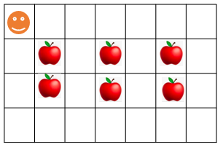

WHILE<HAS APPLE>

REPEAT<3>

GO-DOWN

Answer:

PICK-UP

IF<HAS APPLE>

GO-RIGHT

EXERCICE 2:

|  |  |
| --- | --- |
| Objective | Bring all apples to their respective green box. |
| Maximum number of instructions | 10 |
| Allowed instructions | GO-UP GO-DOWN GO-LEFT GO-RIGHT PICK-UP DROP REPEAT N-TIME WHILE IF |
| Allowed conditions | <HAS APPLE> |

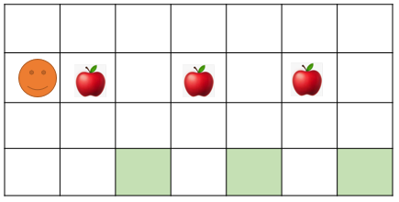

GO-RIGHT

PICK-UP

WHILE<HAS APPLE>

GO-RIGHT

REPEAT<2>

GO-DOWN

Answer:

DROP

REPEAT<2>

GO-UP

EXERCICE 3:

|  |  |
| --- | --- |
| Objective | Pick up all apple and stop at the flag!! |
| Maximum number of instructions | 6 |
| Allowed instructions | GO-UP GO-DOWN GO-LEFT GO-RIGHT PICK-UP IF REPEAT N-TIME WHILE |
| Allowed conditions | <HAS APPLE> <HAS FLAG> <HAS **NO** FLAG> |

GO- LEFT

WHIL<HAS **NO** FLAG>

GO-RIGHT

GO-DOWN

GO-RIGHT

IF<HAS APPLE>

PICK-UP

EXERCICE 4:

What happen at the end?

* How many carrots Jack eats ?
* How many bananas Jack eats?
* Where will be Jack at the end?





















EXERCICE 5:

|  |  |
| --- | --- |
| Objective | Bring all apple to green box and stop at the flag!!  WARNING : you program must work for the 2 cases !!! |
| Maximum number of instructions | 10 |
| Allowed instructions | GO-UP GO-DOWN GO-LEFT GO-RIGHT PICK-UP DROP IF REPEAT N-TIME WHILE |
| Allowed conditions | <HAS APPLE> <HAS CELL DOWN>  <HAS FLAG> <HAS **NO** FLAG> |

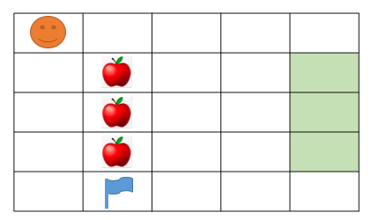Case1:

GO-RIGHT

WHILE<HAS CELL DOWN>

=

GO-DOWN

PICK-UP

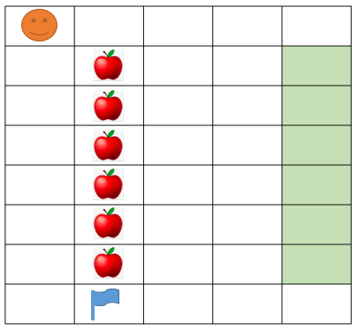Case 2:

REPEAT<3>

GO-RINGT

DROP

REPEAT<3>

GO-LEFT

Be careful NOT to pick up the flag

EXERCICE 6:

|  |  |
| --- | --- |
| Objective | Take all the apple to green box  WARNING: you program must work for the 2 cases!!! |
| Maximum number of instructions | 15 |
| Allowed instructions | GO-UP GO-DOWN GO-LEFT GO-RIGHT PICK-UP DROP IF REPEAT N-TIME WHILE |
| Allowed conditions | <HAS APPLE> <HAS CELL ON RIGHT>  <HAS CELL ON LEFT> |



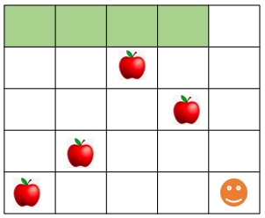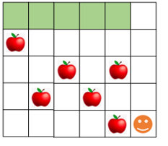

GO- RIGHT

Answer:

WHILE<HAS CELL ON RIGHT>

REPEAT<5>

PICK-UP

IF<HAS APPLE>

GO-UP

DEOP

PICK-UP

REPEAT<5>

EXERCICE 7:

|  |  |
| --- | --- |
| Objective | Take all the apple |
| Maximum number of instructions | 8 |
| Allowed instructions | GO-UP GO-DOWN GO-LEFT GO-RIGHT PICK-UP DROP  IF  REPEAT N-TIME WHILE |

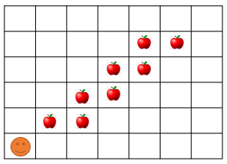

REPEAT<4>

Answer:

GO-RIGHT

WHILE<APPLE>

GO-UP

IF<APPLE>

PICK-UP

GO-RIGHT

EXERCICE 8:

|  |  |
| --- | --- |
| Objective | Take all the apple and go to the green cell |
| Maximum number of instructions | 11 |
| Allowed instructions | GO-UP GO-DOWN GO-RIGHT PICK-UP  IF  REPEAT N-TIME WHILE |

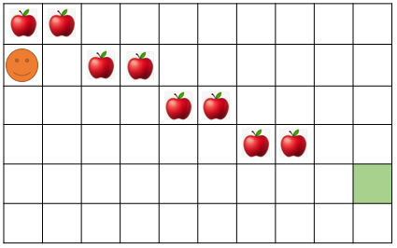

GO-UP

Answer:

WHILE<APPLE>

REPEAT<2>

PICK-UP

GO-RIGHT

GO-DOWN

DROP

EXERCICE 9:

|  |  |
| --- | --- |
| Objective | Bring all apples put in the black cell and go to the green cell.  **Note**: your program must work for the 2 cases!!! |
| Maximum number of instructions | 10 |
| Allowed instructions | GO-UP GO-DOWN DROP GO-RIGHT PICK-UP  IF  REPEAT N-TIME WHILE |
| Allowed conditions | <HAS APPLE> <HAS CELL ON RIGHT>  <HAS CELL ON LEFT> <HAS CELL ON UP> |



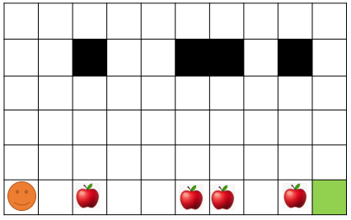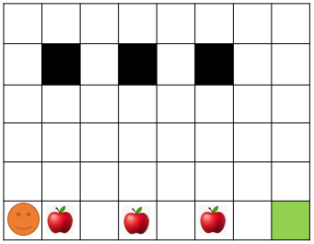

Answer:

WHILE<CELL ON LEFT>

GO-RIGHT

GO-DOWN

REPEAT<4>

DROP

PICK-UP

GO-UP

IF<HAS APPLE>

REPEAT<4>